Problem Description

Traumatic spinal cord injury (SCI) is a debilitating neurological condition with severe socioeconomic impact on the health care system. Since 2015, about 30% of persons with SCI are re-hospitalized for disease of the skin, or respiratory, digestive circulatory, and musculoskeletal diseases[1]. There are approximatively 54 new cases of SCI per one million people (17,730 new cases)[2]. The injured individuals are predominantly male. The age distribution is bimodal with a first peak involving young adults and a second peak for adults over the age of 60. Injuries in this last group, usually result from falls and these patients have worst outcomes than younger patients. More than 90% of SCI cases are traumatic such as traffic accidents, violence, sports or falls (**Figure 1** below). Incomplete tetraplegia is the most frequent neurological outcome (**Figure 2** below).

|  |
| --- |
| **Figure 1: Cause** |
|  |
| **Figure 2: Neurological Level** |
|  |

Source: National spinal cord injury statistical center

SCI are mostly contusion (49% of cases), or lacerations (21%) cases. Compression shows no breach or disruption in the surface anatomy, and presents areas of hemorrhage and necrosis. In contrast, laceration results in clear-cut of the spinal cord, the lesions are dominated with collagenous connective tissue. In massive compression, the cord is pulpified to a varying degree with extensive fibrous scarring[1].

**Figure 3: “The Pathology of Human Spinal Cord Injury: Defining the Problems”**

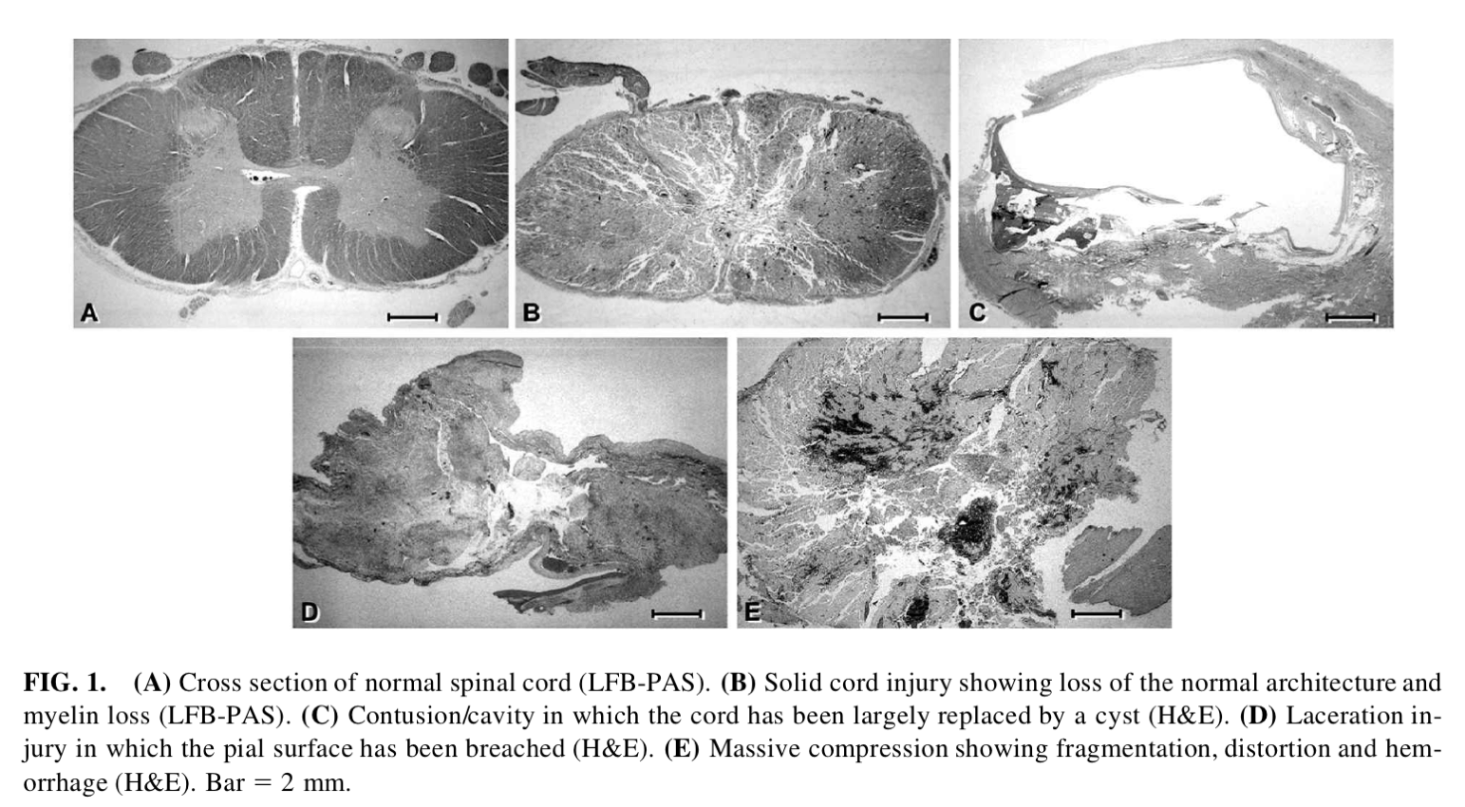

The initial primary injury causes neuronal death (axons and oligodendrocytes), increase in the level of pro-inflammatory cytokines, and recruits inflammatory cells, such as macrophages, neutrophils and lymphocytes in the spinal cord, demyelination, ischemia and hypoxia. This process persists for weeks and initiates a second wave of apoptosis in neurons and oligodendrocytes. In the late phase (weeks to months/years), the injured tissue is isolated from the environment by reactive astrocytes through the formation of a mesenchymal scar. This phase is also characterized by developments of cysts, and syrinx, and Schwannosis [1] (**Figure 4 and 5** below).

|  |  |
| --- | --- |
| **Figure 4: Norenberg et al.**  **Pathophysiology of traumatic. SCI** | **Figure 5: [2]**  **Main cellular targets of cell therapy in SCI** |
|  |  |

Motivation

According to Coherent Market Insight, the spinal cord injury therapeutic market is estimated to be valued at USD 6.7 million in 2021 and is expected to have a compound annual growth rate (CAGR) of 5.1% to reach USD 9.6 million in 2028. North America represents the largest market with 42.1%.

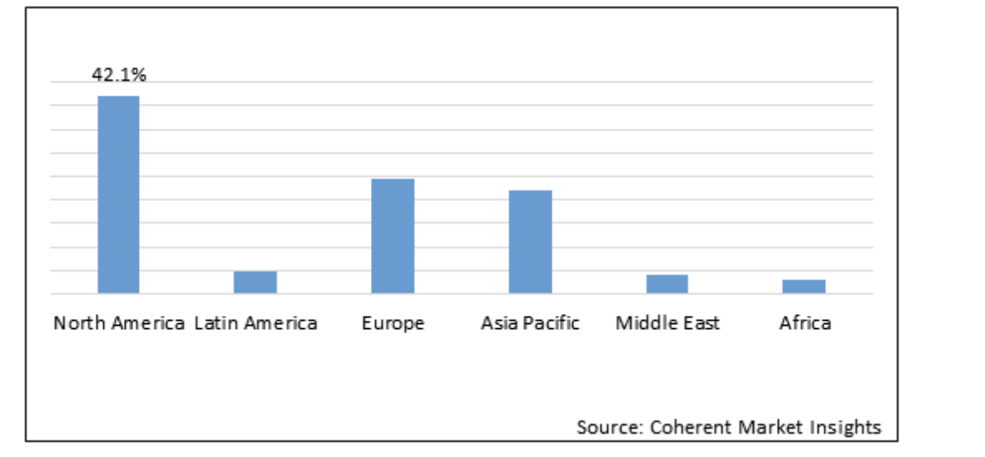

Neuro-Spinal graft targets patients who have suffered a thoracic AIS (American Spinal Injury Association Impairment scale) A traumatic spinal cord injury at neurological level of injury of T2-T12. Compared to a neurological “incomplete” injury (AIS-B, C or D), AIS-A has the least potential improvement, the lowest lifetime survival [3](**Figure 6** below). In term of costs, Medicaid is the only national program covering services that SCI survivors require. Mean annual cost of hospitalization are the highest among persons with AIS-A, AIS-B, or AIS-C injuries with a daily cost of $2601 (2015 US$) [3] (**Figure 7** below).

|  |  |  |
| --- | --- | --- |
| **Figure 6: ASIA Impairment Scale Grade** | **Figure 7: Estimated lifetime expectancy** | |
|  | |  |

The neural-spinal forms an adhesive matrix that can deliver the cells near the injury site for enhancing axon guidance in the spinal cord. In the first clinical trial, conducted by Lineage, OPC1, oligodendrocytes progenitor cells, were injected to individuals with a neurological level of injury between T3 and T11 and with AIS-A. After 10-year follow-up the trial no serious adverse events (SAEs) were reported. In a second trial, escalating doses were administered to 33 participants. No SAEs reported were related to OPC1, 22 participants attained a one-motor-level improvement and 7 attained a two-motor-level improvement on one side of the body.

## C – Solution Landscape

|  |  |  |  |
| --- | --- | --- | --- |
| **Description** | **Advantage** | **Disadvantage or GAP** | **Reference** |
| **Title (you can come up with a short descriptor if the technology doesn’t have a name)**  1-2 sentences describing the  Solution | * Bulleted list | - Bulleted list | Include patent number, bibliography style reference or  company website. |
| **Title (you can come up with a short descriptor if the technology doesn’t have a name)**  1-2 sentences describing the  Solution | * Bulleted list | - Bulleted list | Include patent number, bibliography style reference or  company website. |
| **Title (you can come up with a short descriptor if the technology doesn’t have a name)**  1-2 sentences describing the  Solution | * Bulleted list | - Bulleted list | Include patent number, bibliography style reference or  company website. |
| **Title (you can come up with a short descriptor if the technology doesn’t have a name)**  1-2 sentences describing the  Solution | * Bulleted list | - Bulleted list | Include patent number, bibliography style reference or  company website. |
| **Example**  **Meso Biomatrix Scaffold** Kensey Nash is developing a porcine mesothelaial matrix for  soft tissue repair including nerve  conduits. | * naturally-derived matrix facilitates cell infiltration and growth factor retention * easy to handle surgically (short hydration time durable, deformable) | - matrix material is derived from another animal (pig) | http://www.kense ynash.com |

[table]

Table with 5 distinct solutions.

[text]

Summary of descriptions, advantages, disadvantages, references. A well-written paragraph summarizing and referencing the content in the table

Include a careful consideration of the advantages and disadvantages of each solution. Review the logical argument of the text to provide contrast between the solutions and a gap analysis/description.

Provide a thoughtful summary and analysis of the differences in the available solutions.

Use the text section to do more than just *repeat* the information in the table in the summary paragraph – use the text section to describe trends and gaps in the table to set up a natural conclusion of how your selected product is able to address those gaps. It may be helpful to organize the section into smaller paragraphs for each specific gap you have identified.

## D – Solution Description

|  |  |  |  |
| --- | --- | --- | --- |
| **Need / Criteria** | **Unit of Measure** | **Ideal Value / Range** | **Reference** |
| **Title**  1-2 sentences describing the criteria |  | - | Include bibliography style reference |
| **Title**  1-2 sentences describing the criteria |  | - | Include bibliography style reference |
| **Title**  1-2 sentences describing the criteria |  | - | Include bibliography style reference |
| **Title**  1-2 sentences describing the criteria |  | - | Include bibliography style reference |
| **Example**  **Thrombogenicity**  Indwelling vascular catheter should not cause thrombosis. This is a severe safety risk to the patient. | * mg of thrombus formation in animal study | - none or less than a legally marketed comparator device | Preclinical Device Thrombogenicity Assessments: Key Messages From the 2018 FDA, Industry, and Academia Forum, ASAIO Journal |

[table]

Table should include 4-6 thoughtful and critical design criteria. Criteria should also align with the requirements and constraints of the clinical problem. Criteria should include specific descriptions, scientific details, quantitative/functional criteria, and references for how the solution meets the criteria. Table should be filled out completely.

[paragraph text]

Summarize the process of selecting the design criteria and the associated metrics (based on the clinical need/problem statement). It’s important to include references to support the choice of these design criteria. Try to be specific to the CTE criteria we’re studying in the course and the identified problem statement and not address medical treatments in general.

Describe *how* the solution/specific CTE product works. Provide details on how the solution functions (mode of action).

Describe how the design of solution matches up with the design criteria. Explain the correlation between the function/design of the solution and the selected design criteria.

## E – Verification and Validation

There is often a lot of information you can include in this section. It needs to be structured into a logical analysis showing the verification and validation success, in *technical* detail, as a take home "This really works" message to the reader.

How do these studies map to specific, quantitative, design criteria from the solution description?

Verification

[Use subheadings for each part]

Verification is typically a bench or animal study, where you are assessing the quantitative feature/specification of the device itself - thickness, bioactive proteins, strengths, biocompatibility, etc. Not typically clinical trials, those are validation.

Use the text to describe at least one key verification study. Explain how the reported data demonstrates the *most* important aspect for proof of concept. Show how the data connects to the design inputs.

Please focus on at least one quantitative verification and provide details on the method, outcome, and connection to design requirements. It helps to include at least one specific quantitative example from the papers and connect that example to the intended design parameter for that metric.

Validation

Describe the methods and outcomes of at least one validation study. Connect the methods and outcomes to the needs of the intended population described earlier in the project.

If the company/lab have not published clinical trial results, then focus on the specific parallels, methods, and outcome from the available studies to the eventual human population.

**Wrapping up:** A concluding summary of the verification function and the validation scope (relating the validation to the patient population in the Background section) would be helpful. This section is almost the end of the paper so really try to give the reader a take home "it works" message.

## Conclusions

[Only submitted in the final report]

Provide a short closing paragraph which summarized the key-take-away messages from your analysis and ties the whole project together. Link back to the problem statement.

## References

1. [use MLA format]

**References**:

[1] M. D. Norenberg, J. Smith, and A. Marcillo, “The Pathology of Human Spinal Cord Injury: Defining the Problems,” *Journal of Neurotrauma*, vol. 21, no. 4, pp. 429–440, Apr. 2004, doi: 10.1089/089771504323004575.

[2] J. Desai, S. Steiger, and H.-J. Anders, “Molecular Pathophysiology of Gout,” *Trends in Molecular Medicine*, vol. 23, no. 8, pp. 756–768, Aug. 2017, doi: 10.1016/j.molmed.2017.06.005.

[3] E. M. Dukes, S. Kirshblum, A. A. Aimetti, S. S. Qin, R. K. Bornheimer, and G. Oster, “Relationship of American Spinal Injury Association Impairment Scale Grade to Post-injury Hospitalization and Costs in Thoracic Spinal Cord Injury,” *Neurosurgery*, vol. 83, no. 3, pp. 445–451, Sep. 2018, doi: 10.1093/neuros/nyx425.

1. National spinal cord injury statistical center.
2. Jain NB, Ayers GD, Peterson EN, et al. Traumatic spinal cord injury in the United States, 1993-2012. JAMA. 2015;313(22):2236-2243.